Department of Bachelor of Computer Application

PROJECT DOCUMENTATION

Flipkart Product Analysis Using Power BI

Project Type | Data Analytics Project
Technology Stack | - Power Bi  - Dax Query
Institution | Institute of Engineering & Management (IEM)
Team Members | - Moupiya Saha  - Tanishka Saha  - Sangita Das  - Swastika Das  - Shovon Das

CERTIFICATE
This is to certify that the project report entitled "Flipkart Product Analysis Using Power BI" is a bonafide work carried out by Ms. Sangita Das, in partial fulfillment of the requirements for the award of the Bachelor of Computer Applications (BCA) degree under Institute of Engineering & Management (IEM), West Bengal, during the academic session 2024–2028.
The work presented in this report has been completed under my supervision and guidance. To the best of my knowledge, this project has not been submitted, either in whole or in part, to any other university or institution for the award of any degree or diploma.

Project Guide,
Name: Partha Koley
Date:
Place: Kolkata

DECLARATION
I, Sangita Das, hereby declare that the project report entitled "Flipkart Product Analysis Using Power BI" submitted in partial fulfillment of the requirements for the award of the Bachelor of Computer Applications (BCA) degree under Institute of Engineering & Management (IEM), West Bengal, is my original work carried out under the guidance of my project supervisor.
I further declare that this project has not been submitted previously, either in full or in part, to any other university or institution for the award of any degree, diploma, or certificate. The information and references used in this report have been acknowledged appropriately.
I understand that if any statement made in this declaration is found to be incorrect, I shall be responsible for the consequences as per the rules and regulations of the University.

Date:
Place: Kolkata

Acknowledgement
I would like to express my sincere gratitude to my project guide and faculty members for their valuable guidance, continuous support, and encouragement throughout the development of this project, "Flipkart Product Analysis Using Power BI." Their suggestions and feedback helped me successfully complete this work.
I am also thankful to my institution for providing the necessary resources and learning environment to carry out this project. I would like to acknowledge Microsoft Power BI for providing an efficient platform for data visualization and business intelligence, which made it possible to transform raw data into meaningful insights.
Finally, I would like to thank my family and friends for their constant motivation, support, and encouragement during the completion of this project.

Table of Contents
Sl. No. | Contents | Page No.
1 | Certificate | 2
2 | Declaration | 3
3 | Acknowledgement | 4
4 | Abstract | 7
5 | Introduction | 8
6 | Problem Statement | 9
7 | Dataset | 10
7.1 | Data Source | 10
7.2 | Dataset Overview | 10
7.3 | Data Fields | 11
7.4 | Data Cleaning | 11
8 | Methodology | 12
8.1 | Architecture and Structure | 12
8.2 | Analytical Pipeline | 13
9 | Dashboard Overview | 14
9.1 | KPI Summary Cards | 15
9.2 | KPI Dashboard | 15
9.3 | Category Analysis Dashboard | 16
9.4 | Price Analysis Dashboard | 16–17
9.5 | Rating Analysis Dashboard | 17–18
9.6 | Map Visualization | 18
9.7 | Filters (Slicers) | 19
10 | Project Insights | 20
11 | Limitations | 21
12 | Future Scope | 22
13 | Conclusion | 23
14 | References | 24

List of Tables
Table No. | Table Title | Page No.
Table 1 | Fields of the Dataset | 11
Table 2 | KPI Summary Cards | 15
Table 3 | Category Analysis KPI | 16
Table 4 | Rating Analysis KPI | 18
Table 5 | Filters (Slicers) | 19

List of figures

Figure No. | Figure Title | Page No.
Figure 1 | Dataset of Flipkart Dashboard | 10
Figure 2 | Overall Dashboard of Flipkart Product | 14
Figure 3 | KPI Dashboard | 15
Figure 4 | Price Analysis KPI | 17
Figure 5 | Map Visualization | 18

Abstract
The Flipkart Product Analysis Dashboard is an interactive Business Intelligence project developed using Microsoft Power BI. The purpose of this project is to analyze Flipkart product data to understand product distribution, pricing, customer ratings, discounts, and category-wise performance. The dashboard enables users to explore large amounts of product information through interactive visualizations, making it easier to identify trends and support business decision-making.
The project transforms raw product data into meaningful insights by performing data cleaning, transformation, modeling, and visualization. Various KPIs, charts, maps, and filters help users quickly understand the overall performance of products across different categories and brands.
Overall, this dashboard demonstrates how Power BI can convert raw e-commerce data into valuable business insights that help improve pricing strategies, inventory planning, and customer satisfaction.

Keywords: Power BI, Flipkart, Business Intelligence, Data Visualization, Dashboard, Product Analysis, Data Analytics, E-commerce, Data Cleaning, Customer Ratings.

1.Introduction
The rapid growth of the e-commerce industry has generated enormous amounts of product-related data, making data analysis essential for understanding customer preferences and business performance. Organizations use Business Intelligence (BI) tools to transform raw data into meaningful insights that support informed decision-making. Among these tools, Microsoft Power BI has become one of the most popular platforms due to its powerful data visualization, interactive dashboards, and analytical capabilities.
This project, "Flipkart Product Analysis Using Power BI," aims to analyze product information from the Flipkart e-commerce platform to gain insights into product categories, pricing, discounts, customer ratings, and brand performance. The project involves importing the dataset into Power BI, cleaning and transforming the data using Power Query, creating calculated measures using DAX (Data Analysis Expressions), and developing interactive dashboards to visualize key business metrics.
The dashboard enables users to monitor important performance indicators such as Total Products, Average Selling Price, Average Discount, Average Rating, Category-wise Distribution, Brand Performance, and Price Comparison. Interactive filters and slicers allow users to explore data dynamically, making the dashboard useful for business analysts, sellers, and decision-makers.
By converting complex product data into clear visual reports, this project demonstrates how Business Intelligence can improve business decisions, identify market trends, and enhance customer satisfaction.

2.Problem Statement
- Sales Performance Tracking:
  - Flipkart needs to track how sales are performing over time across various product categories and regions.
  - The company is interested in understanding if there are seasonal trends or time periods (e.g., festivals, sales campaigns) where sales increase or decrease.
- Customer Behaviour & Satisfaction:
  - Analysing customer ratings and understanding the relationship between customer satisfaction and sales is critical for improving product offerings.
  - Flipkart wants to identify which products are driving higher satisfaction and which are underperforming.
- Payment Method Preferences:
  - The company needs insights into how customers are paying for their orders (e.g., UPI, Credit Card, COD) and whether certain payment methods are associated with higher sales volumes or customer satisfaction.
- Regional Sales Distribution:
  - Flipkart wants to assess the sales performance across different regions to identify areas with high demand and potential growth opportunities.
Expected Outcome: The sales dashboard should provide comprehensive, visually appealing, and interactive insights into the key metrics that drive Flipkart’s sales performance. This data will help the team make informed decisions about inventory management, marketing strategies, pricing, and customer service improvements.

3. Dataset
3.1 Data Source:
The dataset used in this project is a Flipkart Product Dataset collected from publicly available e-commerce product listings. The dataset contains detailed information about products listed on Flipkart.
Source:
- Public Flipkart Product Dataset
- CSV format imported into Microsoft Power BI
3.2 Dataset Overview:
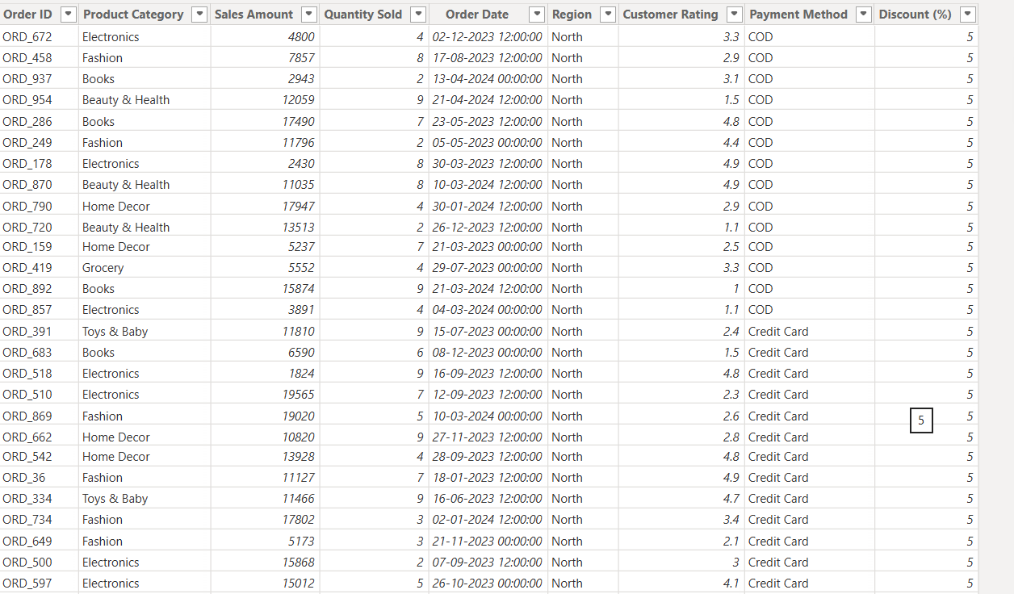
Figure 1: Dataset of Flipkart Dashboard

3.3 Data Fields:

Field Name | Description
Product Name | Name of the product
Category | Product category
Brand | Brand name
Selling Price | Current selling price
Original Price | Original product price
Discount (%) | Percentage discount
Rating | Customer rating
Reviews | Number of customer reviews
Location | Product location (if available)
Table 1: Fields of the dataset
3.4 Data Cleaning:
Several preprocessing steps were performed before creating the dashboard.
Steps:
- Removed duplicate records
- Handled missing values
- Corrected inconsistent category names
- Converted price columns into numeric format
- Removed unwanted symbols from prices
- Standardized brand names
- Formatted rating values
- Created calculated columns where necessary
These steps improved the accuracy and quality of the dashboard.

4. Methodology
4.1 Architecture and Structure:
The project follows the standard Power BI workflow.
Flipkart Dataset
│
▼
Data Collection
│
▼
Data Cleaning
(Power Query)
│
▼
Data Transformation
│
▼
Data Modeling
│
▼
DAX Calculations
│
▼
Dashboard Creation
│
▼
Business Insights

4.2 Analytical Pipeline:
The analytical process consists of the following stages:
Step 1: Data Collection-Import Flipkart dataset into Power BI.
Step 2: Data Cleaning-Perform cleaning using Power Query.
Step 3: Data Transformation-Convert data types and prepare columns.
Step 4: Data Modeling-Create relationships and calculated measures.
Step 5: Dashboard Design-Develop interactive visualizations.
Step 6: Business Analysis-Generate insights using filters and KPI cards.

5. Dashboard Overview:
The Overall Dashboard provides a summary of the complete dataset.
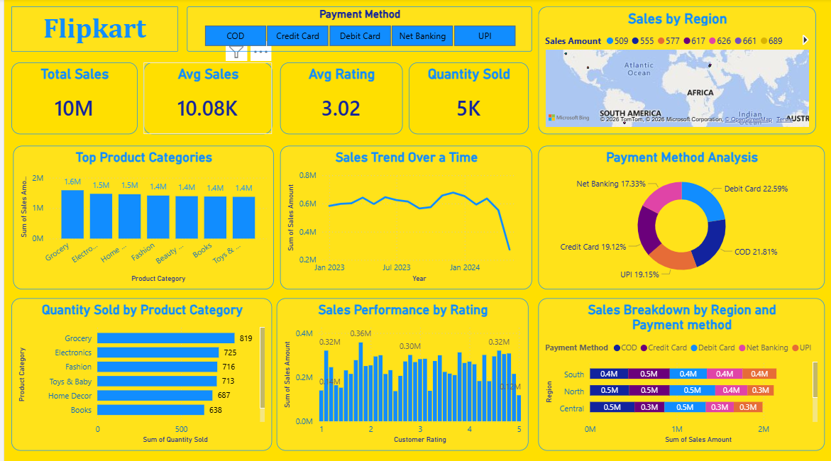
Figure 2: Overall Dashboard of Flipkart product
It includes:
- Total Products
- Average Rating
- Average Discount
- Average Selling Price
- Category Distribution
- Location-wise Product Distribution
- Price Comparison
- Interactive Filters (Slicers)
The dashboard allows users to quickly understand the overall performance of Flipkart products.

5.1 KPI Summary Cards:
KPI | Value
Total Sales | ₹10,126,169
Total Orders | 1,006
Total Quantity Sold | 4,924
Average Sales/Order | ₹10,066
Average Customer Rating | 3.00 ⭐
Average Discount | 14.36%
Total Product Categories | 9
Regions Covered | 6
Payment Methods | 7
Table 2: KPI Cards
5.2 KPI Dashboard:
┌─────────────┬─────────────┬─────────────┬─────────────┐
│ Total Sales │ Total Orders│ Total Qty │ Avg Rating │
│ ₹10.13 M │ 1,006 │ 4,924 │ 3.00 ★ │
└─────────────┴─────────────┴─────────────┴─────────────┘

┌─────────────┬─────────────┬─────────────┬─────────────┐
│ Avg Discount│ Categories │ Regions │ Payment │
│ 14.36% │ 9 │ 6 │ 7 │
Figure 3: KPI Dashboard

5.3 Category Analysis Dashboard:
KPI Cards
- Top Category by Sales
- Highest Quantity Sold Category
- Highest Rated Category
- Average Category Discount
Recommended Charts
- Clustered Bar Chart → Sales by Product Category
- Column Chart → Quantity Sold by Category
- Donut Chart → Category-wise Sales Share
- Tree Map → Sales Contribution by Category
Example:
Electronics ₹2.8 M
Fashion ₹2.1 M
Home ₹1.6 M
Beauty ₹1.2 M
Sports ₹0.9 M
Books ₹0.7 M
Others ₹0.8 M
Table 3: Category Analysis KPI
5.4 Price Analysis Dashboard:
KPI Cards
- Highest Sales Amount
- Lowest Sales Amount
- Average Sales Amount
- Total Revenue
Charts
- Histogram → Sales Amount Distribution
- Box Plot (optional)
- Scatter Plot → Discount vs Sales
- Column Chart → Average Sales by Category
Recommended Visuals:
Average Sales by Category

Electronics ███████████

Fashion ████████

Home ██████

Beauty █████

Books ████
Figure 4: Price Analysis KPI
5.5 Rating Analysis Dashboard:
KPI Cards
- Average Rating
- Highest Rating
- Lowest Rating
- Average Reviews (if available)
Charts
- Bar Chart → Average Rating by Category
- Column Chart → Rating by Region
- Scatter Plot → Rating vs Sales
- Donut Chart → Rating Distribution

Example:
Average Rating
Electronics 4.5
Fashion 4.2
Home 4.0
Beauty 3.9
Sports 4.3
Table 4: Rating Analysis KPI
5.6 Map Visualization:
Use a Filled Map or Bubble Map.
Location Field
Region
Display
- Sales Amount
- Quantity Sold
Example:
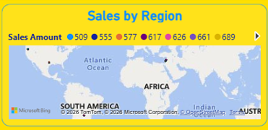
Figure 5: Map Visualization
Bubble size = Sales Amount
Color = Quantity Sold

5.7 Filters (Slicers):

Filter | Purpose
Product Category | Filter by category
Region | Regional analysis
Order Date | Monthly/Yearly analysis
Payment Method | Payment-wise analysis
Customer Rating | High/Low ratings
Discount (%) | Discount analysis
Sales Amount | Price range
Quantity Sold | Quantity filter
Table 5: Filters

6. Project Insights
The Flipkart Product Analysis Dashboard provides several valuable business insights by analyzing sales, customer ratings, discounts, product categories, payment methods, and regional performance. These insights help businesses understand market trends and improve decision-making.
Key Project Insights:
- The dataset contains 1,006 customer orders, providing a comprehensive overview of product sales and customer purchasing behavior.
- The total sales amount is ₹10,126,169, indicating strong business activity across multiple product categories.
- A total of 4,924 products were sold, showing significant customer demand on the Flipkart platform.
- The average sales per order is approximately ₹10,066, which helps evaluate customer spending patterns.
- The average customer rating is 3.00 out of 5, suggesting moderate customer satisfaction and highlighting opportunities to improve product quality and customer experience.
- The average discount offered is 14.36%, showing that promotional discounts play an important role in attracting customers.
- The dashboard covers 9 different product categories, enabling category-wise performance comparison and helping identify high-performing product segments.
- Sales data is distributed across 6 regions, allowing businesses to compare regional performance and identify potential growth opportunities.
- Seven different payment methods are used by customers, indicating diverse payment preferences and supporting digital payment adoption.
- Interactive filters (slicers) enable users to analyze sales based on category, region, payment method, customer rating, discount percentage, quantity sold, and order date, making the dashboard dynamic and user-friendly.
- The combination of Power Query, DAX measures, KPI cards, charts, and maps transforms raw sales data into meaningful business insights that support strategic decision-making.
7. Limitations
Although the project provides useful insights into Flipkart product sales and customer behavior, it has some limitations:
- The analysis is based on a sample dataset of 1,006 records, which may not fully represent all Flipkart products and sales.
- The dashboard uses historical data only and does not include real-time sales information.
- The dataset contains limited attributes, such as sales amount, quantity, rating, discount, region, and payment method, which restricts deeper business analysis.
- Customer demographic information (such as age, gender, or location details) is not available in the dataset.
- The project does not include predictive analytics or machine learning models for future sales forecasting.
- Profit, shipping cost, return rate, and inventory data are not included, limiting comprehensive business performance analysis.
- The dashboard's insights depend on the accuracy and completeness of the available dataset.
These limitations provide opportunities for future enhancements, such as integrating real-time data, adding predictive analytics, and including additional business metrics for more comprehensive analysis.

8. Future Scope
- Real-Time Data Integration: Connect the dashboard with live Flipkart sales data for real-time analysis.
- Sales Forecasting: Use machine learning models to predict future sales trends and customer demand.
- Customer Segmentation: Analyze customer behavior to create personalized marketing strategies
- Inventory Management: Integrate inventory data to monitor stock levels and prevent shortages.
- Advanced Analytics: Include profit analysis, seasonal trends, and customer lifetime value for deeper insights.
- Mobile Dashboard: Develop a mobile-friendly Power BI dashboard for easy access on smartphones and tablets.
- Automated Reports: Schedule automatic data refresh and report generation for timely business updates.
- Cross-Platform Analysis: Expand the project to compare Flipkart data with other e-commerce platforms like Amazon and Meesho.

9. Conclusion
The Flipkart Product Analysis Dashboard successfully demonstrates the use of Microsoft Power BI as an effective Business Intelligence tool for analyzing e-commerce data. The project converts raw sales data into interactive visualizations that help users understand sales performance, customer ratings, discounts, regional trends, and product category performance.
Using Power Query, the dataset was cleaned and transformed to improve data quality. DAX measures were used to calculate key business metrics, while interactive visualizations such as KPI cards, bar charts, line charts, donut charts, maps, and slicers provided meaningful insights into the dataset.
The dashboard enables users to quickly identify high-performing product categories, monitor sales trends, compare regional performance, evaluate customer satisfaction through ratings, and understand the impact of discounts on sales. These insights can support better business decisions related to pricing strategies, inventory planning, promotional campaigns, and customer engagement.
Overall, this project demonstrates how Power BI can transform large volumes of e-commerce data into clear, interactive, and easy-to-understand dashboards. In the future, the project can be enhanced by integrating real-time Flipkart data, incorporating predictive analytics, applying machine learning models for sales forecasting, and developing customer segmentation techniques to provide even deeper business insights.

10. References
[1] Microsoft Corporation, Microsoft Power BI Documentation. Available: https://learn.microsoft.com/power-bi/
[2] Microsoft Corporation, Power Query Documentation. Available: https://learn.microsoft.com/power-query/
[3] Microsoft Corporation, Data Analysis Expressions (DAX) Documentation. Available: https://learn.microsoft.com/dax/
[4] Microsoft Learn, Power BI Learning Path. Available: https://learn.microsoft.com/training/powerplatform/power-bi/
[5] Flipkart Internet Private Limited, Flipkart Official Website. Available: https://www.flipkart.com/
[6] Alberto Ferrari and Marco Russo, The Definitive Guide to DAX, 2nd ed., Microsoft Press, 2019.
[7] Marco Russo and Alberto Ferrari, Analyzing Data with Microsoft Power BI and Power Pivot for Excel, Microsoft Press, 2016.
[8] Rob Collie and Avichal Singh, Power Pivot and Power BI, Holy Macro! Books, 2017.
[9] Kaggle, Flipkart Sales/Product Dataset (Public Educational Dataset). Available: https://www.kaggle.com/
[10] Kimball, R., & Ross, M., The Data Warehouse Toolkit: The Definitive Guide to Dimensional Modeling, 3rd ed., Wiley, 2013.

